**Blog Entry of Interactive Visualization**

Chongdan Pan

SI649

**Introduction**

I build five visualizations in this project, and they all aim at enabling the audience to know Red Lake’s performance in certain aspects. Some of them even allow the audience to explore other counties by themselves. Various kinds of interaction are implemented through clicking, selection, hovering, and widgets.

During the design, I feel that it’s really hard to provide details and an overview when there is such a huge amount of data. I came up with the idea of adding more interactivity between different visualizations. All five visualizations can be viewed alone, but they’ll work better when they’re connected. For example, when the audience is investigating a county with a specific ranking, the county's geographic location will be highlighted on the map immediately. In this way, the audience can know where the county is and the performance of other counties close to it.

For the narrative, I simplified the original text and used a Martini Glass Structure in some sections. The audience can explore the information of other counties after I introduce Red Lake.

**Visualization 1**

The learning objective of the first visualization is to enable the audience to identify the distribution of the nature amenity index and other related factors among the U.S and different states. The audience can also get the standardized value of these fields of any county they’re interested in. The bar chart should also help a user identify the rank of counties with extreme performance among certain states. My inspiration is from my static project as well as the article “Every county in America, ranked by scenery climate.”

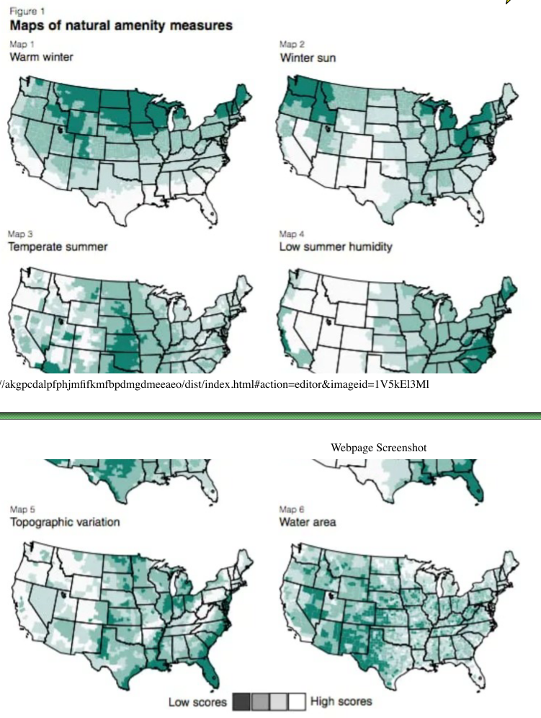

Figure 1. Inspiration from article

It may be redundant to list all fields on the page, so I add two widgets for the audience to select the field and state of interest. The white color used in the original visualization makes it hard to identify counties in it, so I use the “redyellowblue” scheme. When the audience selects different options from the widget, the title for the visualization will be changed as well.

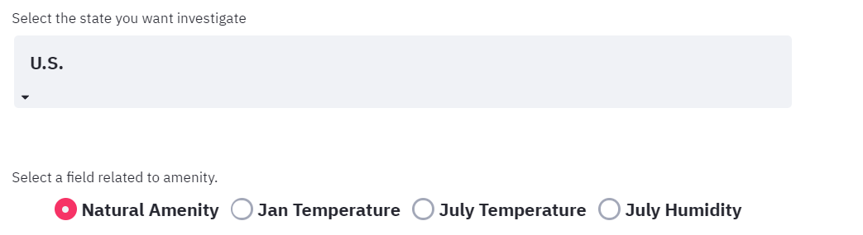

Figure 2. Selection Widget

In my first design of this visualization, there is only a U.S. map with a tooltip for the audience to find the information counties of interest by themselves. I used “redyellowblue” color theme because it’s aesthetical, clear, and unpolitical.

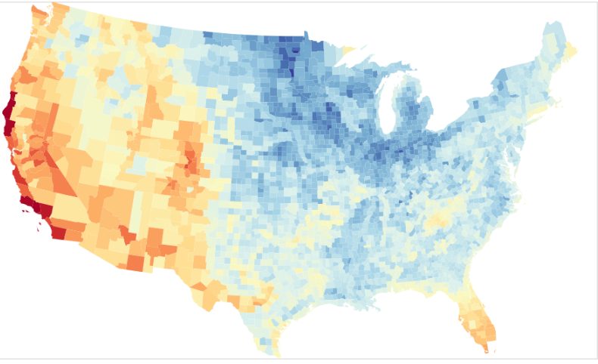

Figure 3. The map

To make the visualization closer to the main topic, I want to provide the users with an easier way to find the county of interest through interaction. So I design a bar chart that ranks the counties in a given area. When the audience clicks the county with a specific ranking, its location will be highlighted on the map. The bar chart for ranking only listed counties with the worst performance. However, the values are too close for the audience to tell the difference.

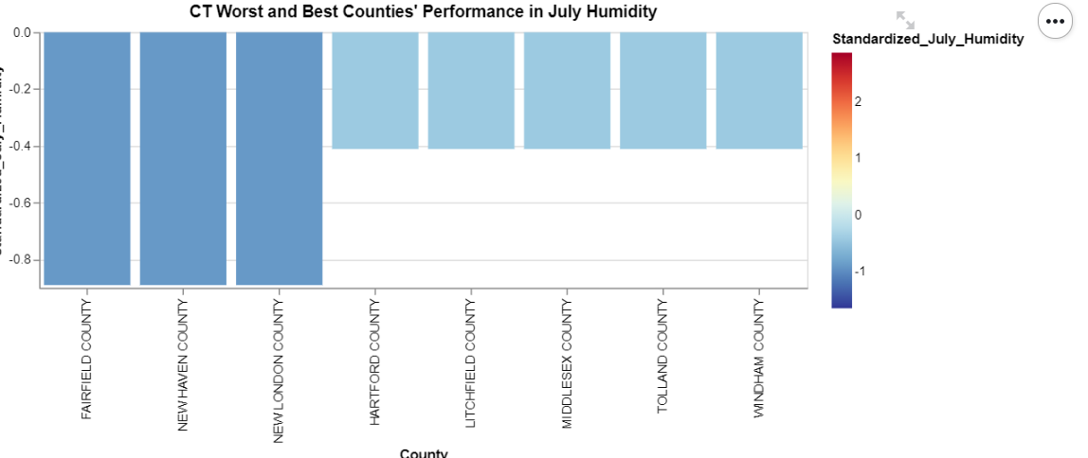

Figure 4. The bar chart with worst counties

Therefore, I add more counties with the best performance on the ranking. After the revision, the bar chart not only provides more information to the audience but also looks prettier. Based on the theory we learned from the course, a visualization should provide as much meaningful information as possible, so I carefully tune the number of bars in the chart so that it’s informative and aesthetical.

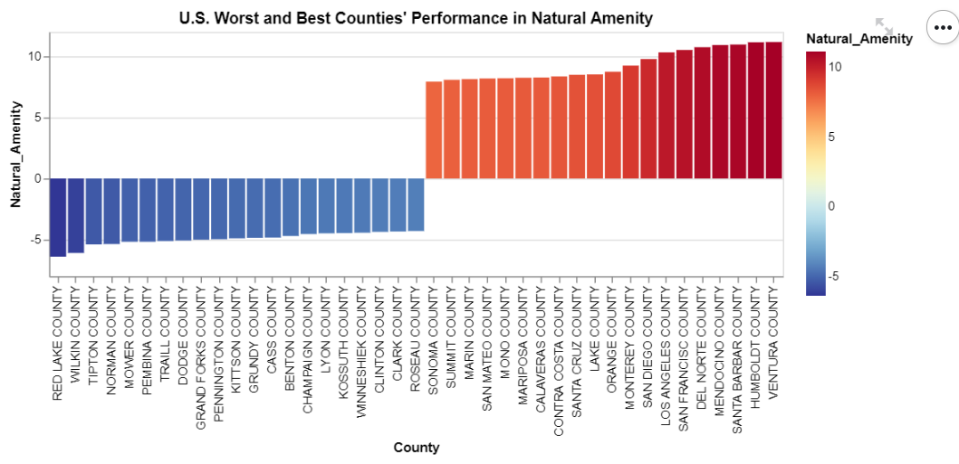

Figure 5. The tunned bar chart with ranking on best and worst

There is no specific hierarchy between the two charts because they can be viewed separately with tooltips for detailed information, but I also provide interaction for the user to connect them.

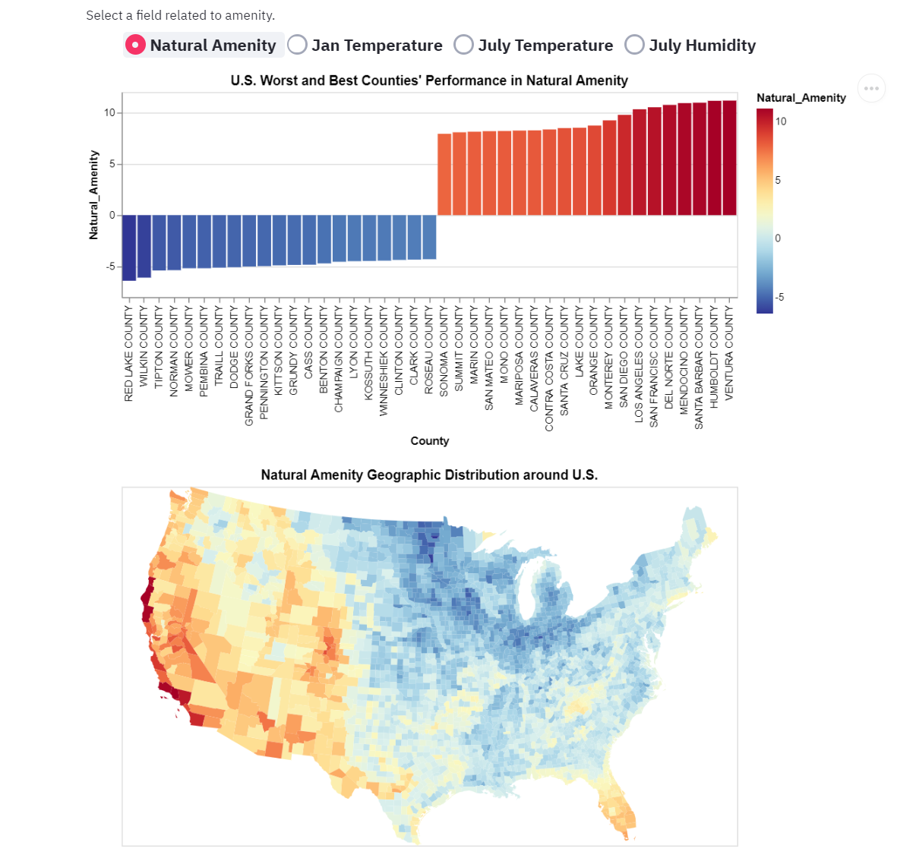

Figure 6. The final delivery of the visualization

**Visualization 2**

The learning objective of the second visualization is to enable the audience to notice the Red Lake’s superiority in low Gini Index and low unemployment rate. Since there are so many counties for comparison, it’s extremely hard for the audience to find out where Red Lake is without a geographic map. My solution is to use a heatmap with binned bar chart so that the audience can know Red Lake’s relative performance easily.

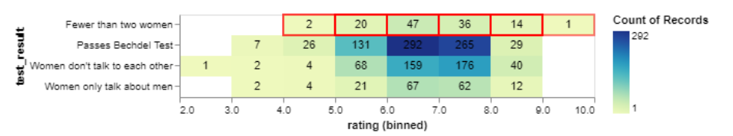

Figure 7. Heatmap Inspiration

The inspiration comes from our previous lab assignment, where we encode the count of records through color and text. I also highlight the bin containing the Red Lake with a red border so that we can quickly find it. To provide information about separate comparisons, I also add bar charts on the two axes.

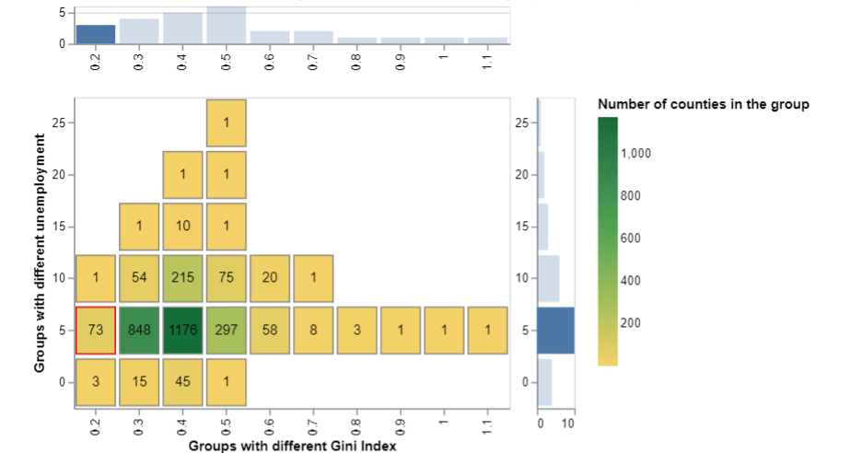

Figure 8. My heatmap design

In this way, we can know that Red Lake is in the first ranking group of the Gini index and a second ranking group of the unemployment rate. The audience knows there how many counties are in each group easily as well. For example, there are only three counties with higher or equal performance in Gini Index and unemployment rate than Red Lake.

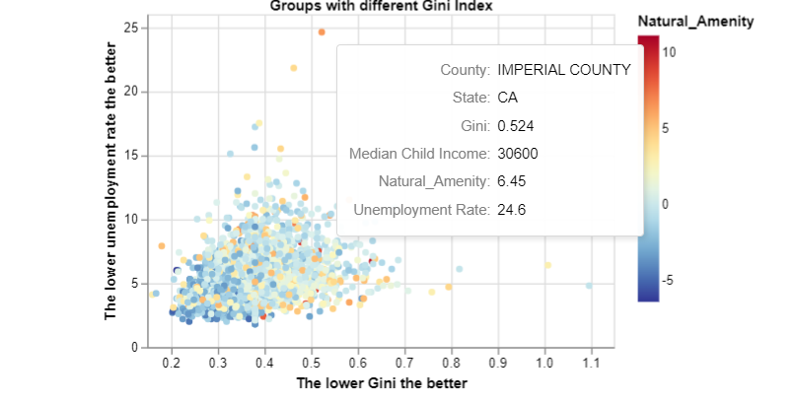

Figure 9. The scatter plot for economic index

Then I apply Martini Glass Structure so that audience can explore the performance of counties of interest by themselves. To provide more detailed information, I use a scatter plot with a tooltip. Following the idea of the first visualization, I encode the natural amenity with the “redyellowblue” color again so that the user can quickly find Red Lake among blue dots. In addition, since there are too many dots, I provided the user with zooming and slider bars for filtering.

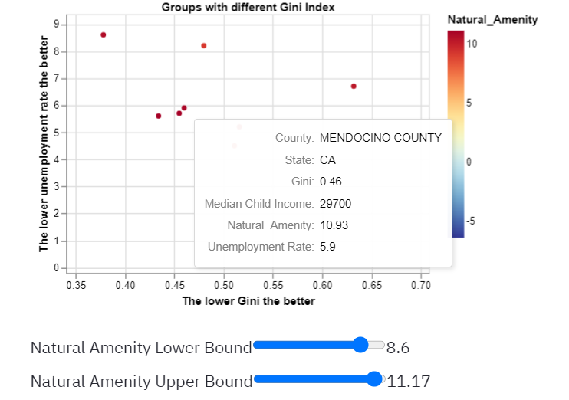

Figure 10. Filtering on the scatter plot

To make these visualizations more expressive and interesting, I add mores interactivity between them and the user. When the user digs into a county’s details on the scatter plot, its group on the first heatmap will be highlighted. In this way, the user can not only know the value of the county's economic index but also the relative performance among all counties.

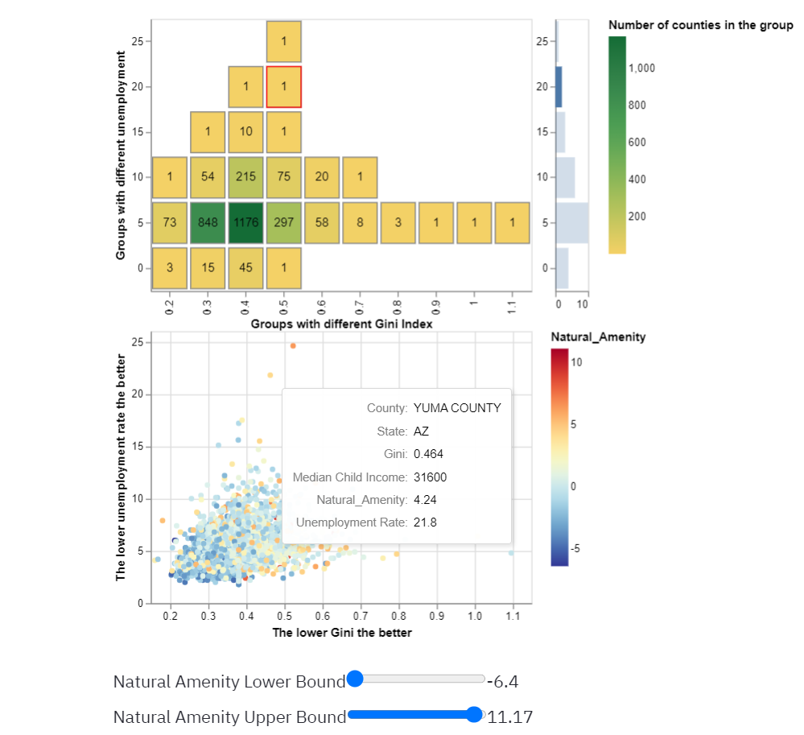

Figure 11. Interaction between two visualizations

Therefore, the visualization provides the users with different ways to investigate the economic performance of different counties. If they know the name or location of the county, they can find the natural amenity from the first visualization. Then they can find detailed information about the county by using the filtering slider bar. If they just want to have an overview of counties in a certain range of unemployment or natural amenity, they can just move the slider or zoom the scatter plot. When the user’s mouse hovers on the dot, its group will be highlighted correspondingly.

**Visualization 3**

The third visualization aims at letting the audience know Red Lake from multiple aspects, such as health, safety, etc. Based on our class material, I thought of using a radar plot or parallel coordinates to visualize multiple variables, but I don’t know how to implement them through Altair.

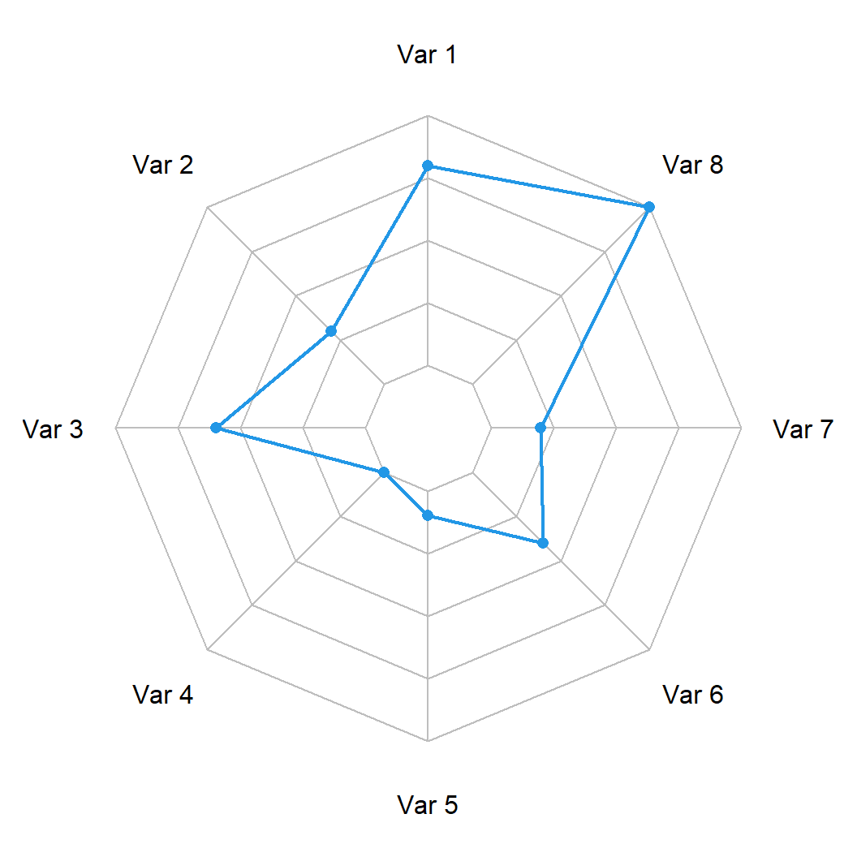

Figure 12. Radar plot

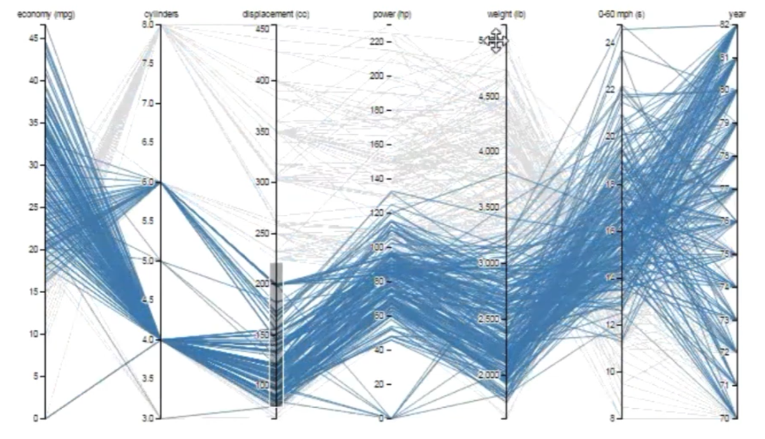

Figure 13. Parallel coordinates

However, I’m still inspired by the parallel coordinates to mark rules based on the different values. In this way, the audience can know how better Red Lake is than the U.S. average level in crime rate, life expectancy, etc. Note that when the audience selects different field from the widget, the subtitle will be changed as well. Therefore so that the audience can get a specific rank of Red Lake in this field.

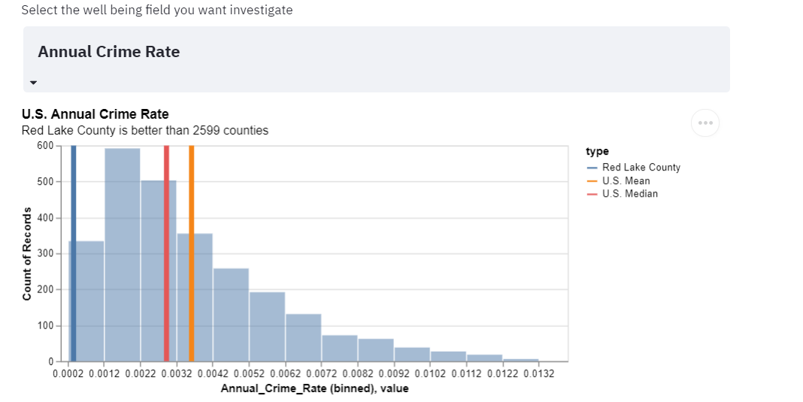

Figure 14. Final delivery of visualization about well-being at Red Lake